OPM – SCRD – New System Deployment Guide

Revision History
Author | Revision Number | Date | Comments
lukashov | 1.0 | 01/29/2014
lukashov | 1.1 | 01/30/2014
lukashov | 1.2 | 02/21/2014 | Added instructions for OPM Web Application with Business Rules Engine integration assembly. Removed instructions for OPM Frontend Account And Payment Integration Assembly and BRE Interest and Deduction Calculation module assembly.

1. Organization of Submission 3
2. Application Setup 3
3. Environment Configuration 3
1.1 RHEL VM 3
1.2 Microsoft SQL Server VM 7
4. Deployment Instructions 12
1.3 OPM Web Application with Business Rules Engine integration assembly 12
1.4 OPM Data Migration module assembly 14
1.5 Test Data 15
5. Starting 15
1.6 OPM Web Application with Business Rules Engine integration assembly 15
1.7 OPM Data Migration module assembly 15
6. Verification 15
7. Resource Contact List 16

Organization of Submission

In this private task you need to deploy the following Modules into a VM:
1. OPM Web Application with Business Rules Engine integration assembly https://software.topcoder.com/review/actions/DownloadFinalFix?uid=279841
2. OPM Data Migration Module : http://apps.topcoder.com/wiki/download/attachments/93159486/opm_-_data_migration_-_processor_module_assembly_1.0.0_submission.part1.rar?version=1 and http://apps.topcoder.com/wiki/download/attachments/93159486/opm_-_data_migration_-_processor_module_assembly_1.0.0_submission.part2.rar?version=1
3. Test Data: http://apps.topcoder.com/wiki/download/attachments/93159486/SCRD-Test+Data_finalfix_v2.rar?version=1

Application Setup

The application is deployed with the following stack
- Java 6 (http://www.oracle.com/technetwork/java/javase/downloads/index.html)
- JBoss EAP 6.1 (http://www.jboss.org/jbossas/downloads/)
- Ant 1.8.1 (http://ant.apache.org/)
- PostgreSQL 9.2.4 (http://www.postgresql.org/)
- Microsoft SQL Server 2012

The following 3rd party libraries are deployed on the packaged with the submission
- Drools 5.5
- jBPM 5.4
- Jackson 2.3.1
- Spring MVC 3.2.3
- Spring Security 3.1.4
- Hibernate 4.2.3
- Joda-Time 2.3
- JUnit 4.10

The application modules are deployed in two virtual machines
- RHEL 6.4 (ec2-54-221-102-98.compute-1.amazonaws.com)
The RHEL VM contains the major part of the application components (OPM Frontend Miscellaneous module, OPM Data Migration module, BRE Interest and Deduction Calculation module and the Test Data)
- Windows Server 2012 (ec2-54-196-191-38.compute-1.amazonaws.com)
The Windows VM contains only a SQL Server database with the test legacy SCRD application data. It does not contain any modules of the new SCRD application.

Environment Configuration

RHEL VM
Download the required 3rd party software distribution packages
Folder | Description
~/dist/jdk-6u45-linux-x64.rpm.bin | Java 6  http://www.oracle.com/
~/dist/jboss-eap-6.1.0.zip | JBoss EAP 6.1  http://www.jboss.org/
~/dist/pgdg-redhat92-9.2-7.noarch.rpm | PostgreSQL 9.2.4  http://www.postgresql.org/
~/dist/apache-ant-1.8.1-bin.zip | Ant 1.8.1  http://ant.apache.org/

Java 6
chmod +x ~/dist/jdk-6u45-linux-x64.rpm.bin
sudo ~/dist/jdk-6u45-linux-x64.rpm.bin

vim ~/.bash_profile
# JAVA_HOME=/usr/java/jdk1.6.0_45
# export JAVA_HOME
#
# PATH=$PATH:$HOME/bin:$JAVA_HOME/bin

Verification steps
- Verify that JDK is installed and its version is 1.6
$ /usr/java/jdk1.6.0_45/bin/java –version
java version "1.6.0_45"
Java(TM) SE Runtime Environment (build 1.6.0_45-b06)
Java HotSpot(TM) 64-Bit Server VM (build 20.45-b01, mixed mode)

JBoss EAP 6.1
# create a Linux user which jboss will run as
sudo adduser jboss

# extract and install the JBoss runtime
sudo unzip ~/dist/jboss-eap-6.1.0.zip -d /usr/share
sudo ln -s -T /usr/share/jboss-eap-6.1 /usr/share/jboss-as
sudo chown -R jboss:jboss /usr/share/jboss-eap-6.1

# create a JBoss management user
sudo -u jboss /usr/share/jboss-as/bin/add-user.sh
# 1. Management User
# 2. ManagementRealm
# 3. User name: jboss
# 4. Password: G#Nsfkm9j8RBykFG
# 5. no

# allow listening on any IP
sudo -u jboss cp /usr/share/jboss-as/standalone/configuration/standalone.xml /usr/share/jboss-as/standalone/configuration/standalone.xml.orig
sudo -u jboss vim /usr/share/jboss-as/standalone/configuration/standalone.xml
# <interface name="management">
# <inet-address value="${jboss.bind.address:0.0.0.0}"/>
# </interface>
#
# <interface name="public">
# <inet-address value="${jboss.bind.address:0.0.0.0}"/>
# </interface>

# specify the JVM to use
sudo -u jboss cp /usr/share/jboss-as/bin/standalone.conf /usr/share/jboss-as/bin/standalone.conf.orig
sudo -u jboss vim /usr/share/jboss-as/bin/standalone.conf
# JAVA_HOME="/usr/java/jdk1.6.0_45"

# create a RHEL service to run JBoss EAP 6.1 Standalone
sudo ln -s -T /usr/share/jboss-eap-6.1/bin/init.d/jboss-as-standalone.sh /etc/init.d/jboss-as

sudo mkdir /etc/jboss-as
sudo ln -s /usr/share/jboss-eap-6.1/bin/init.d/jboss-as.conf /etc/jboss-as/jboss-as.conf
sudo chown -R jboss:jboss /etc/jboss-as

# set run-as user name
sudo -u jboss cp /usr/share/jboss-eap-6.1/bin/init.d/jboss-as.conf /usr/share/jboss-eap-6.1/bin/init.d/jboss-as.conf.orig
sudo -u jboss vim /etc/jboss-as/jboss-as.conf
# JBOSS_USER=jboss

sudo chkconfig --add jboss-as
sudo chkconfig jboss-as on

# start the service
sudo service jboss-as start
# sudo service jboss-as stop
# sudo service jboss-as restart
# the management console is listening on 0.0.0.0:9990
# the web server is listening on 0.0.0.0:8080

# enable the incoming tcp:8080 connections in the RH firewall
sudo yum install system-config-firewall
sudo system-config-firewall

Verification steps
- Check that JBoss default website opens on ${vm-dns-name}:8080
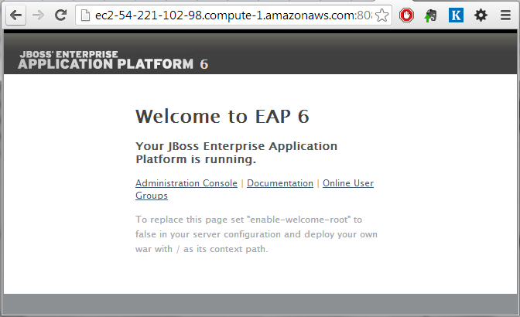
- Check that JBoss Management console opens at localhost:9990 and the username/password match (jboss / G#Nsfkm9j8RBykFG)
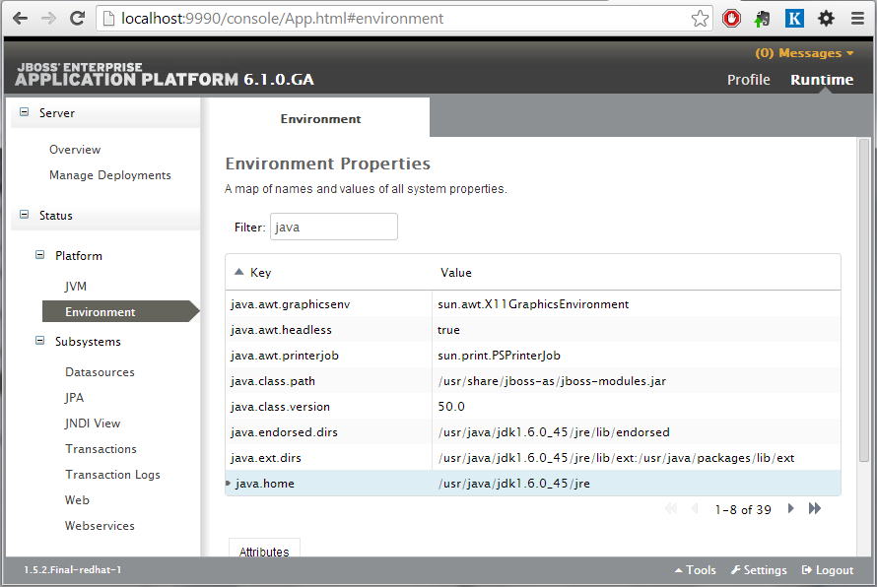
- Check that the JVM version is correct (java.home = /usr/java/jdk1.6.0_45/jre)

PostgresSQL 9.2
sudo yum install ~/dist/pgdg-redhat92-9.2-7.noarch.rpm
sudo yum install postgresql92-server postgresql92-contrib
sudo service postgresql-9.2 initdb
sudo chkconfig postgresql-9.2 on
sudo service postgresql-9.2 start

# create the scrd user and database
sudo -u postgres /usr/pgsql-9.2/bin/psql
# CREATE USER scrd WITH PASSWORD 'MMJUEKAvCJyLvuGj';
# CREATE DATABASE scrd;
# GRANT ALL PRIVILEGES ON DATABASE scrd to scrd;

# add psql to the PATH
export PATH=$PATH:/usr/pgsql-9.2/bin

# allow the scrd user connection to PostgresSQL from the localhost
sudo vim /var/lib/pgsql/9.2/data/pg_hba.conf
# TYPE DATABASE USER ADDRESS METHOD
# host scrd scrd 127.0.0.1/32 md5
# local scrd scrd md5
sudo service postgresql-9.2 reload

Verification steps
- Verify that psql command line tool is installed and the PostgresSQL version is 9.2:
$ /usr/pgsql-9.2/bin/psql –V
psql (PostgreSQL) 9.2.6

- Verify that scrd user can connect to PostgresSQL with the password MMJUEKAvCJyLvuGj:
$ /usr/pgsql-9.2/bin/psql -U scrd -W scrd
Password for user scrd:
psql (9.2.6)
Type "help" for help.

scrd=>

Apache Ant 1.8.1
sudo unzip ~/dist/apache-ant-1.8.1-bin.zip -d /usr/share
vim ~/.bash_profile
# ANT_HOME=/usr/share/apache-ant-1.8.1
# export ANT_HOME
#
# PATH=$PATH:$HOME/bin:$ANT_HOME/bin

Verification steps
- Verify that ant command line tool is installed and the Ant version is 1.8.1:
$ ant -version
Apache Ant version 1.8.1 compiled on April 30 2010

Microsoft SQL Server VM

Configure the Microsoft SQL Server
- Launch the SQL Server Management Studio (run ssms.exe)
- Connect to localhost with the Windows Authentication
- Right click on the localhost SQL Server instance in the Object Explorer
- Select Properteis / Security
- Enable the “SQL Server and Windows Authentication Mode” option
- Click OK
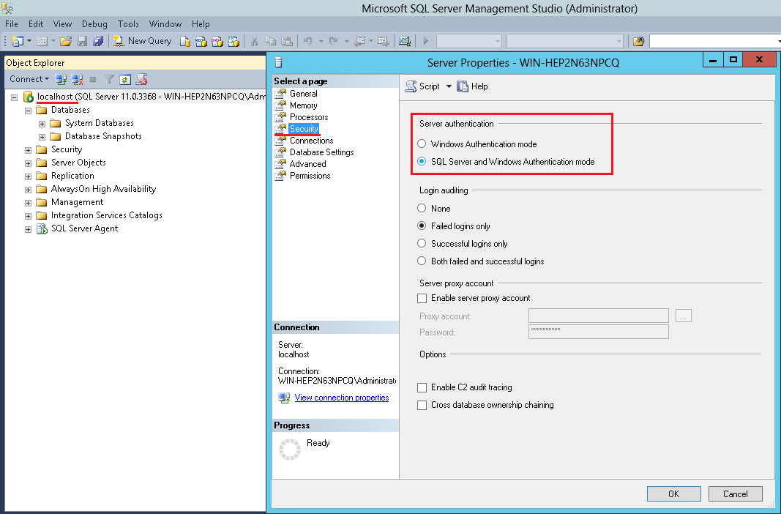

Create the ServiceCredit database
(continue with the SQL Server Management Studio)
- Right click on the Databases in the Object Explorer
- Select “New Database…”
- Give the new database the name ‘ServiceCredit’
- Specify the initial database size (100MB, growing by 100MB) and the initial log size (10MB, growing by 10%)
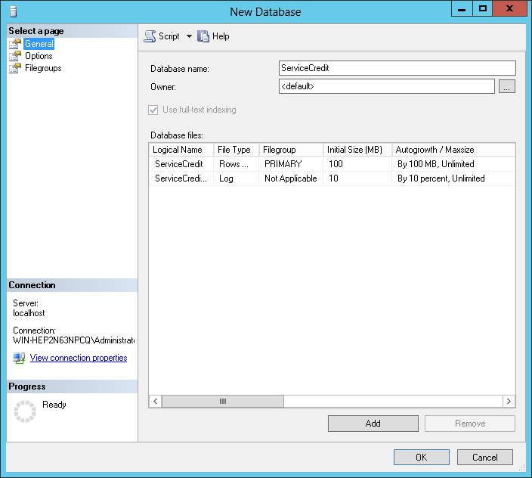
- Set the compatibility level to “SQL Server 2005”
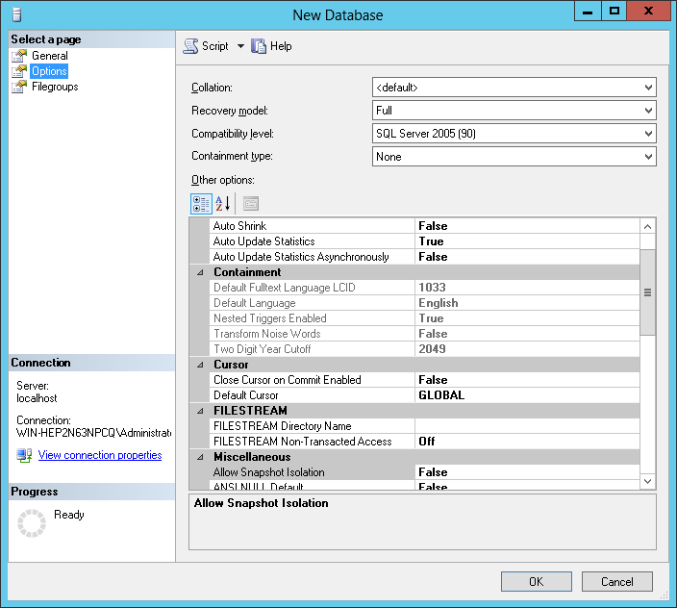
- Click OK to create the database

Create the scrd_migration user with the permissions to read the ServiceCredit database
(continue with the SQL Server Management Studio)
- Right click on the Security / Logins in the Object Browser and select the ‘sdf’ option
- Enter the user name ‘scrd_migration’, select the ‘SQL Server Authentication’ option, enter the password (mtL5JUc7kuUCCpjx), unselect the ‘Enforce password expiration’ checkbox and select the default database for the user to be ‘ServiceCredit’:
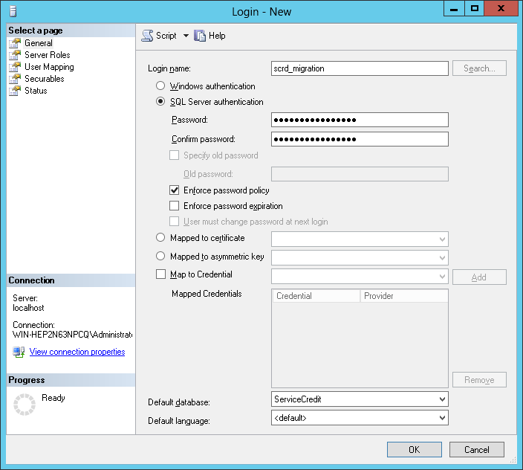
- Switch to the ‘User Mapping’ tab and assign read and write permissions on the ServiceCredit database:
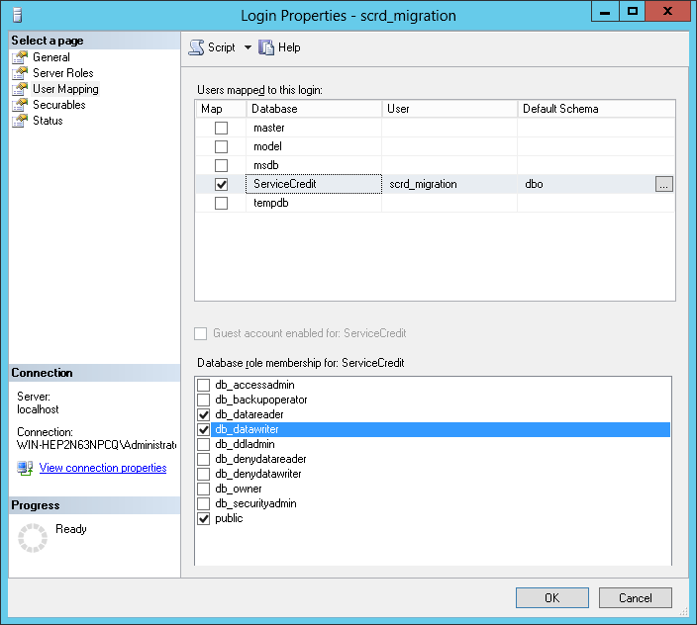
- Click OK to create the user

Deployment Instructions
Copy the deployment packages to a local folder
Folder | Description
~/deploy
~/deploy/bre_integration_ff1 | OPM Web Application with Business Rules Engine integration assembly
~/deploy/data_migration | OPM Data Migration module assembly
~/deploy/test_data | Test Data

OPM Web Application with Business Rules Engine integration assembly
Modify the ~/deploy/bre_integration_ff1/build.properties file
# The installation location of JBoss EAP 6.1
jboss.home=/usr/share/jboss-eap-6.1

# The log path and name used for knowledge execution
log_dir=/var/log/scrd

# The directory that contains the rules files.
opm.drools.rules.directory=/usr/share/scrd-rules

# JDBC details
db.driver=org.postgresql.Driver
db.url=jdbc:postgresql://localhost:5432/scrd
db.user=scrd
db.pass=MMJUEKAvCJyLvuGj

Create the logs directory writable for the jboss user
sudo mkdir -m 755 /var/log/scrd
sudo chown jboss:jboss /var/log/scrd

Deploy the business rules
cd ~/deploy/bre_integration_ff1
sudo mkdir -m 755 /usr/share/scrd-rules
sudo cp conf/rules/* /usr/share/scrd-rules/

sudo chown -R jboss:jboss /usr/share/scrd-rules
sudo chmod 644 /usr/share/scrd-rules/*

Install the PostgresSQL DB Connector for JBoss
cd ~/deploy/bre_integration_ff1
sudo -u jboss cp -r conf/jboss/modules/org /usr/share/jboss-as/modules/system/layers/base/

sudo -u jboss vim /usr/share/jboss-as/standalone/configuration/standalone.xml
# <driver name="postgresql-jdbc4" module="org.postgresql">
# <driver-class>org.postgresql.Driver</driver-class>
# </driver>

Deploy the application
cd ~/deploy/bre_integration_ff1
ant dist-ear
sudo -u jboss cp dist/opm.ear /usr/share/jboss-eap-6.1/standalone/deployments/opm.ear
sudo service jboss-as restart

Run unit tests
# set the permissions necessary for to run the unit tests as ec2-user
sudo chown -R ec2-user:ec2-user /var/log/scrd
sudo chown -R ec2-user:ec2-user /usr/share/scrd-rules

cd ~/deploy/bre_integration_ff1
ant test

# restore the permissions for the jboss user
sudo chown -R jboss:jboss /var/log/scrd
sudo chown -R jboss:jboss /usr/share/scrd-rules

Prepare the database
cd ~/deploy/bre_integration_ff1
ant db-create
ant db-test-data

Verification steps are described in the OPM – Rules Engine – Integrate With Web App Assembly deployment guide document.

OPM Data Migration module assembly
Prepare the source data (Microsoft SQL Server VM)
Execute src/sql/create-ServiceCredit.sql and src/sql/source-data.sql against the ServiceCredit database on the Microsoft SQL Server.

Modify the ~/deploy/data_migration/build.properties file
# The installation location of JBoss EAP 6.1
jboss.home=/usr/share/jboss-eap-6.1

# The log path and name used for knowledge execution
log_dir=/var/log/scrd

# JDBC details
db.driver=org.postgresql.Driver
db.url=jdbc:postgresql://localhost:5432/scrd
db.user=scrd
db.pass=MMJUEKAvCJyLvuGj

# Migration Source Database details
db.sourceDatabaseDriverName=com.microsoft.sqlserver.jdbc.SQLServerDriver
db.sourceDatabaseUrl=jdbc:sqlserver://10.238.162.146:1433;databaseName=ServiceCredit;
db.sourceDatabaseUsername=scrd_migration
db.sourceDatabasePassword=mtL5JUc7kuUCCpjx

Prepare the database
cd ~/deploy/data_migration
and db-drop
ant db-create
ant db-test-data

Compile and execute unit tests
cd ~/deploy/data_migration
ant test

Verification steps are described in the Data Migration - Processor Module Assembly Deployment Guide document.

Test Data
- Create database schema (password: MMJUEKAvCJyLvuGj)
psql -U scrd -W scrd -qf ~/deploy/test_data/schema/create-schema.sql

- Load test data (password: MMJUEKAvCJyLvuGj)
cd ~/deploy/test_data
psql -U scrd -W scrd -qf main_data/scrd_test_data.sql
psql -U scrd -W scrd -qf history_data/history_tables.sql

- Delete test data (password: MMJUEKAvCJyLvuGj)
psql -U scrd -W scrd -qf ~/deploy/test_data/schema/clear-data.sql

Starting

OPM Web Application with Business Rules Engine integration assembly
Prepare the database
cd ~/deploy/bre_integration_ff1
ant db-create
ant db-test-data

Start JBoss (sudo service jboss-as restart). The frontend application is automatically started when the JBoss server is started.

Application is then available on http://ec2-54-221-102-98.compute-1.amazonaws.com:8080/scrd
(user1 / 123456)

OPM Data Migration module assembly
Prepare the database
cd ~/deploy/data_migration
and db-drop
ant db-create
ant db-test-data

Compile run the migration
cd ~/deploy/data_migration
ant exec-migration

Verification
The verification steps are described in the corresponding deployment documents for each module.

Resource Contact List
Name | Resource Email
lukashov

